**CASE STUDY TASKS**

**CREATION OF AZURE VM**

**STEPS AND SCREENSHOT**

**Task1: sign in with valid username and password.**

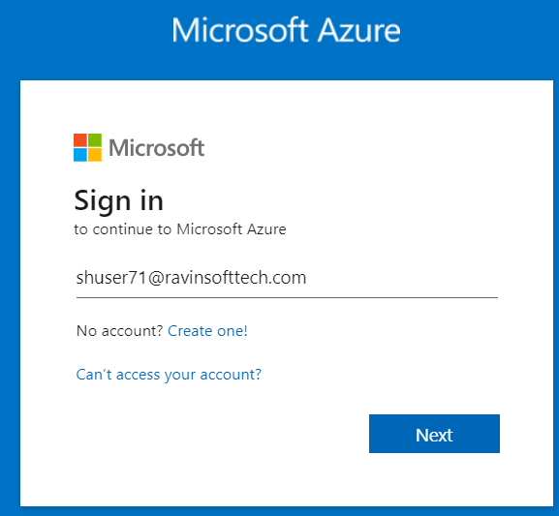

**Task2: create a virtual machine by clicking on virtual machines tab.**

**Task3: select the relevant project details in terms of hardware, network, availability, and software configuration.**

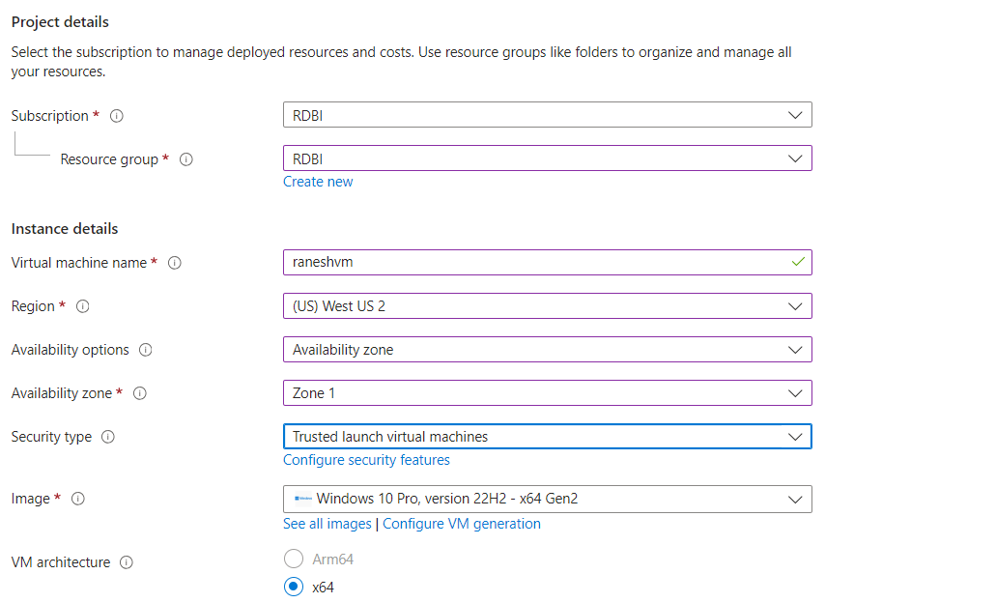

**Task4: deploy your virtual machine successfully.**

**Azure Devops**

**Task1: create a new project with agile workflow.**

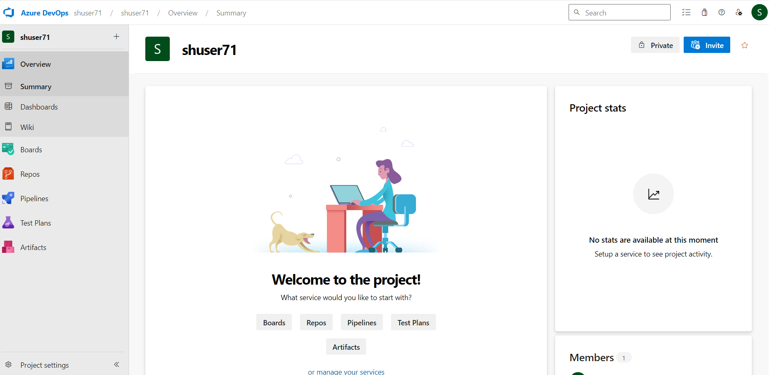

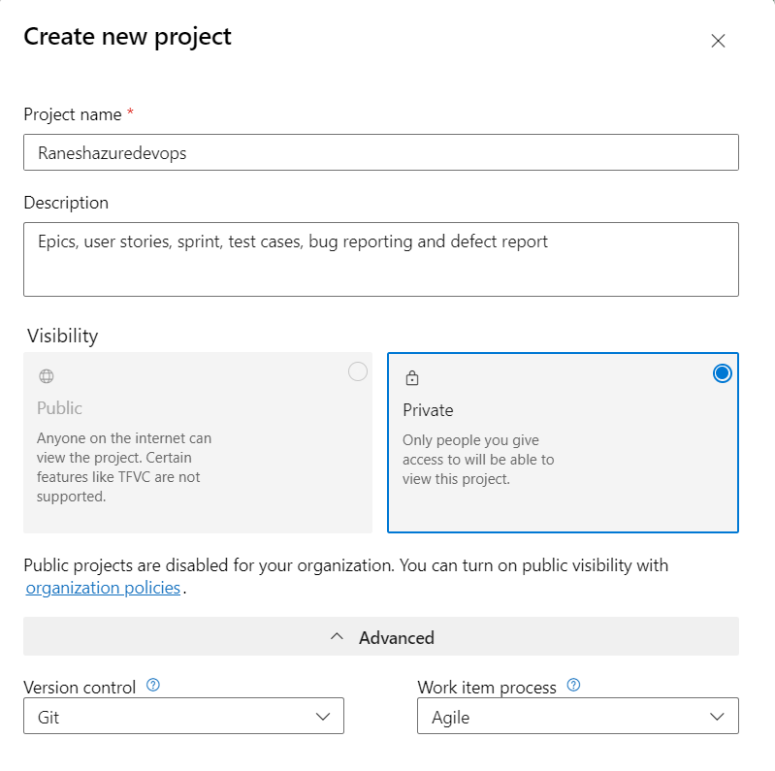

**Task2: create user stories, testcases, identify bugs among others.**

**Test cases:**

**User Story:**

**Task:**

**Bugs:**

**Sample testcase**

**Sample bug:**

**Sample Task:**

**Board:**

**Github Actions:**

**Task1: install vscode and git on your virtual machine**

**Task 2: clone the repository using git clone command.**

**Task 3: add remote origin using git remote add origin**

**For adding remote origin, configure your username and email id.**

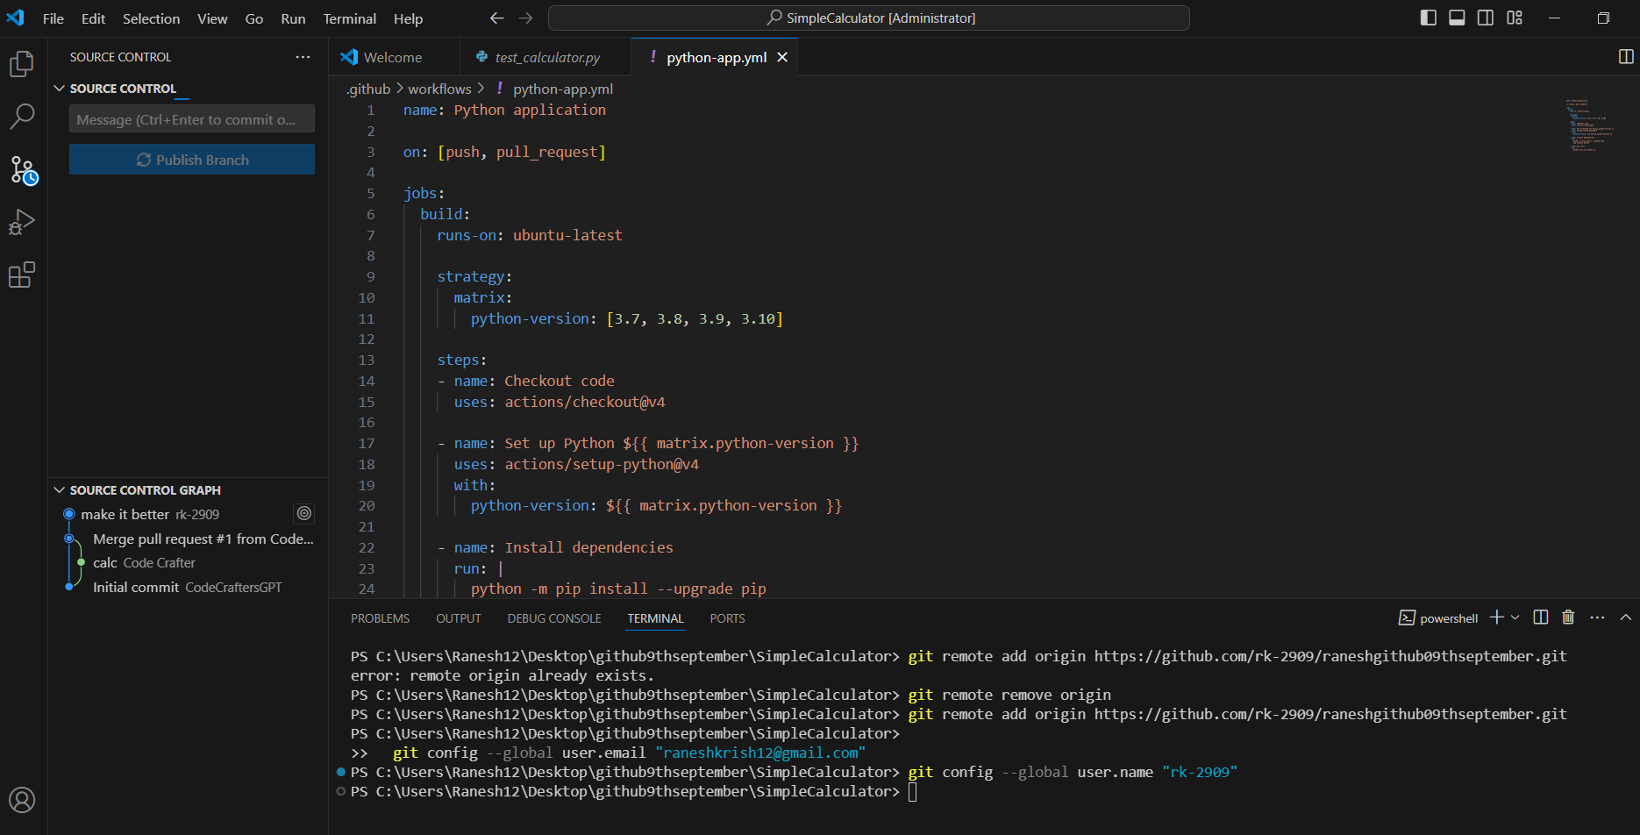

**Task4: create yml file in .github/workflows folder, commit changes to your repository after adding destination repository**

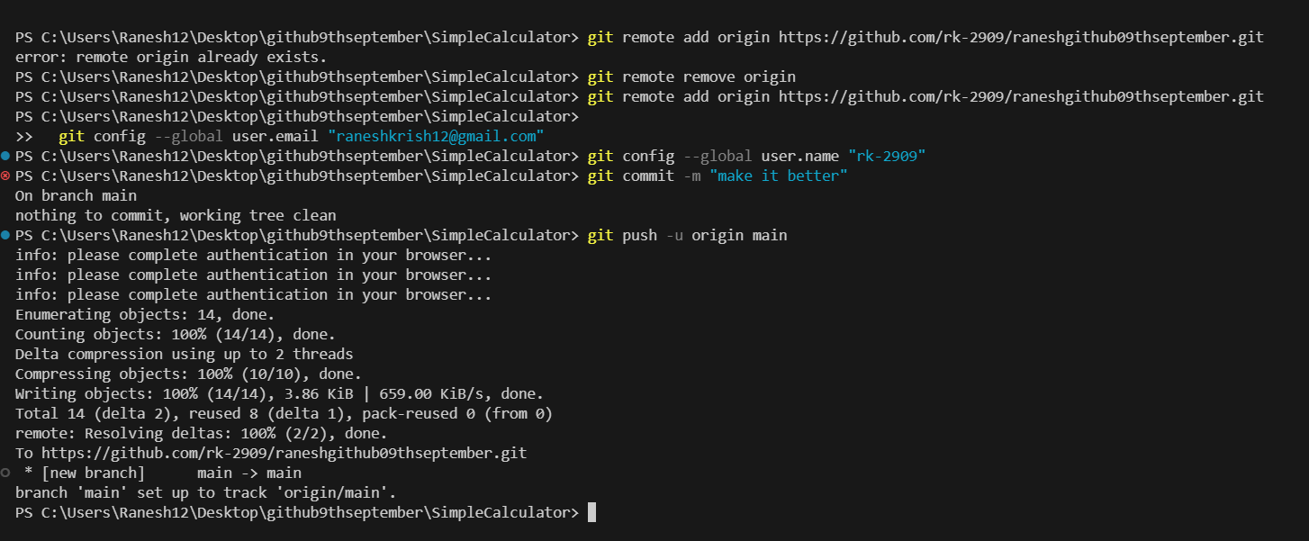

**Task5: go to .github/workflows folder, and run your pipeline. Ensure that the build is successful.**



